The world is seeking a solution to the climate crisis. Agriculture is the only industry capable of providing it.
Johan C. Løken
Former Minister of Agriculture
Aftenposten of June 11th carried a prominent feature article by Professor Stein Ringen. It commenced as follows: “Daily news coverage can easily lead us to conclude that the world is in a wretched state. Yet it still makes sense to remain enthusiastic, because we know from experience that human ingenuity and initiatives have often resolved our difficulties.”
The article’s headline was both optimistic in tone and easily understood: “Today’s world – much better than it seems”.
Ringen substantiates his claim that the world is much better than it seems by the following statement: “At the turn of the century, the standard of living for the world’ s six billion people was better than it had been 40 years previously for the three billion who then inhabited the planet.”
The world is seeking a solution to the climate crisis. My claim is this: Plants, both those on land and those under the sea, can provide this solution and save us! And there is no other industry than agriculture capable of taking on the task involved.
Countries with a well organised agricultural sector can point to formidable growth. The most effective regions experience overproduction, while real prices for agricultural products are steadily decreasing.
The Norwegian government’s Perspective Report includes a graph that depicts the changes taking place in the country’s industries in terms of their relative share of the working population.
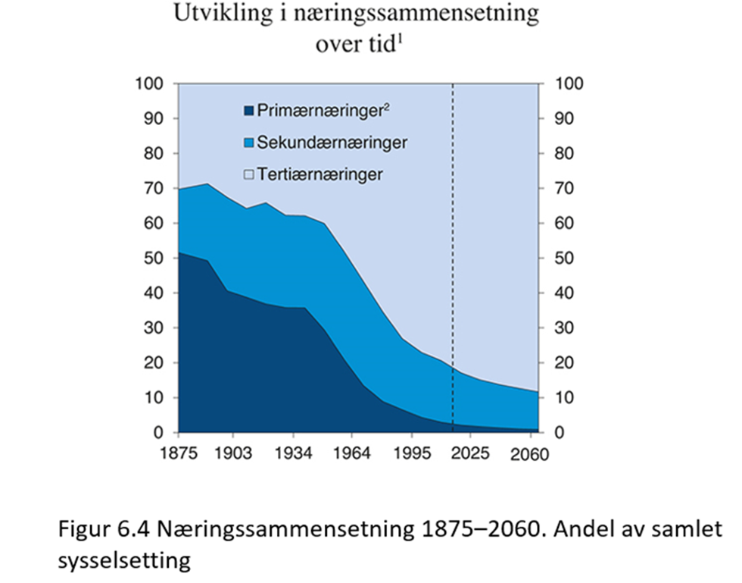
Industries engaged in utilising biological resources are termed primary industries by the Ministry of Finance. Very few people are now employed in these industries, which means that they offer tremendous potential for growth and increased productivity.

The basis for primary industries
Carbon dioxide is the most important raw material of plants. It is a factor input that is freely available in ever greater volumes. By substantially increasing our utilisation of plant matter, we can replace fossil fuels by a non-finite, renewable source. The sun provides an obviously inexhaustible source of energy for photosynthesis. And it is obtained free of charge.
Moreover, the plant realm has a great capacity for biologically capturing and storing carbon. Prior to the Paris climate summit, France – a leading agricultural producer – launched an important initiative.
This “4 per 1000” initiative shows how the earth’s soil can be used for carbon storage.
All plant material basically reverts to the atmosphere in the form of various organic compounds, most typically carbon dioxide. This is the case for the food digested by humans and animals. It is also the case when we burn wood and, not least, for all the plant matter that is not utilised and which is taken up by the atmosphere during decomposition.
But these biological processes do not emit more carbon atoms than they absorb.

Growing interest in biochar
Around the world there is a rapidly growing interest in biochar. Biochar is produced by taking care of plant matter that would otherwise decay.
The carbon that otherwise would have been released into the atmosphere is retained by means of biological storage.
Soil to which biochar has been added becomes more productive, which leads to the increased production of animal feed, food, fibre, timber and biomass for energy purposes.
The United Nations Environment Programme (UNEP), which is currently headed by Erik Solheim, presented its latest Emissions Gap report at the end of last year. The starting point for their deliberations is the need for what are termed negative emission measures. The report emphasises that improved forestry management, plus the planting of trees in non-forest areas, are extremely promising measures in this respect.

Mitigating the impact of climate change
The biochar strategy is ingenious because carbon storage increases the productivity of the land. This means that we obtain more food and timber without intensifying land utilisation.
The scope of the global, green cycle is ten times greater than that of fossil emissions. The plant matter utilised, or which decomposes, releases a volume of greenhouse gases that is ten times greater than the gases emitted by using coal, oil and gas. And the ability of plants to recapture carbon is even greater, which means that the impact of climate change is mitigated.

The new bio-economy
Increasing carbon storage in the biosphere is incredibly effective. Trees are uniquely capable of providing storage while serving as a means of production at the same time. Other plants decay if they are not used.
Countries with the required expertise utilise their renewable resources considerably more effectively than others, as numerous scientific milieux all contribute to productivity growth in agriculture. In a similar way, bio-technology is applied in order to convert waste products into biomass for food, fuel and advanced chemicals.
For many years, the USA has been making intensive and wide-reaching efforts to establish this new bio-economy. By 2030 the volume of plant matter produced will have increased between three and five times.
The IT revolution is also assisting the bio-economy. Precision agriculture boosts production and reduces the need for fertiliser and plant protection.

A new agricultural revolution
We can now confidently maintain that a new agricultural revolution is within reach. But we need to mobilise the world’s farming community, through measures that combine new and older technologies, in order to provide sufficient food and renewable energy, while safeguarding the climate and conserving biological diversity.
Stein Ringen soundly confronted the philosophy of Malthusianism which teaches that population growth must inevitably lead to famine and starvation. Yet a form of neo-Malthusianism emerged in the columns of Aftenposten just three days later.
In an extensive piece headlined “Can Gunhild Stordalen provide the world with the food it needs?”, journalist Joacim Lund claims that food production is one of the biggest causes of the climate crisis. And he declares that red meat is the biggest culprit.
However, the production of red meat represents the only way of utilising those major areas of land where only grass can grow. And ruminants do not emit more carbon atoms than those which the plants they eat have captured through photosynthesis.

